Latif Reid
Advanced Programming
Professor Sazegar
Ethics and Data Analysis

- Introduction
The purpose of this ethics and data analysis assignment is to test your knowledge in how to use fast API’s, navigate through the google cloud, and how to utilize http websites through the fast API’s and google cloud.

- Screenshots
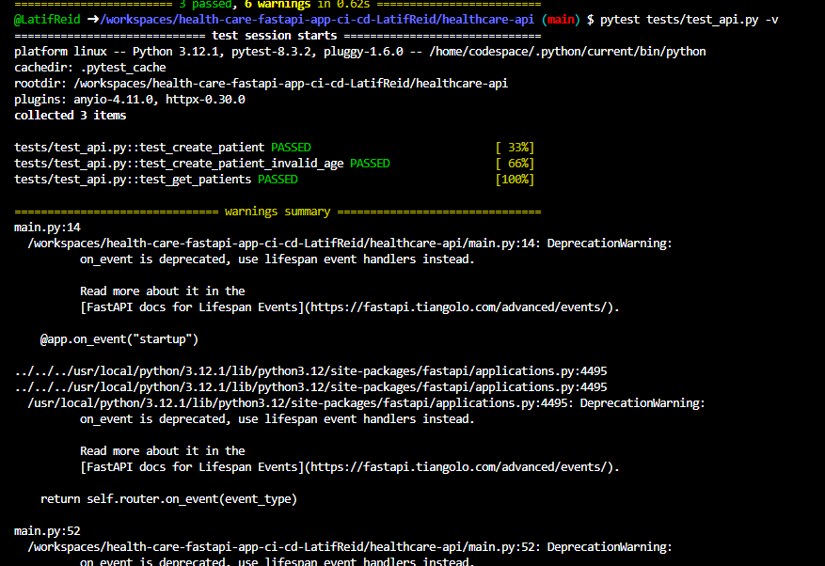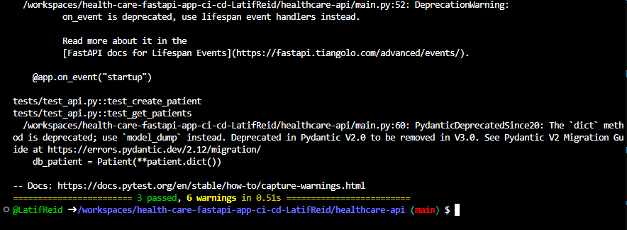
These two screenshots show the results of the testing of the pytest from the terminal in vs code.

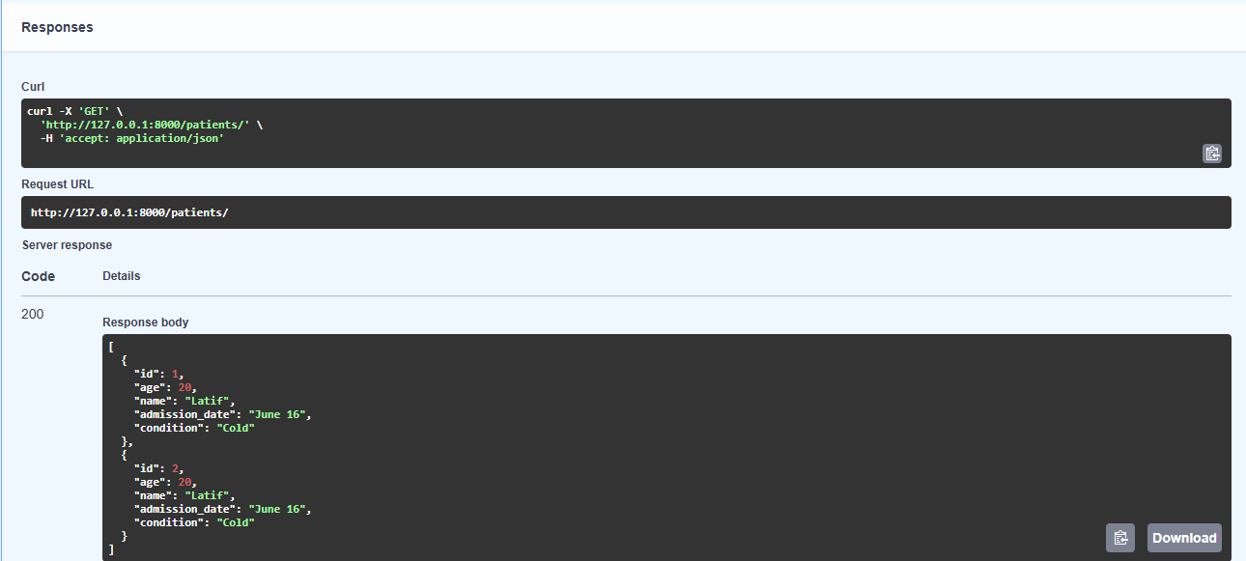
This screenshot above shows the results of adding a new patient into the fats API and updating the patients list on the URL website.

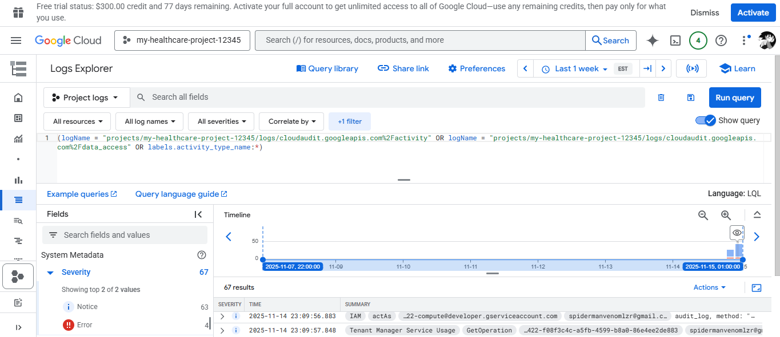
This screenshot shows the healthcare project in the google cloud.

- conclusion
This assignment was good to work with until part 4. I was having trouble with the google cloud website and I couldn’t access certain things to progress through the assignment but other than that and part 5 of step 3. Everything else was fine.
GitHub URL: https://github.com/ClarkAtlantaUni/health-care-fastapi-app-ci-cd-LatifReid.git

